Data Analysis Report

Prepared by

Vasireddy Bindu Hasitha

Objective

In India, the most common type of crime is murder. The current homicide rate in India is 3.08 per 100,000 people. The main aim of this project is to look at the victim trend through time as well as murder victims by state.

Scope

The data set consists the data of victims (female and male) from year 2001 to 2010 and divided based on their age group

1. Above 50 years
2. Between 10 to 15 years
3. Between 15 to 18 years
4. Between 18 to 30 years
5. Between 30 to 50 years
6. Up to 10 years

In this project we are considering 10 states:

* Andaman & Nicobar
* Andhra Pradesh
* Arunachal Pradesh
* Assam
* Bihar
* Chandigarh
* Chhattisgarh
* Delhi
* Goa
* Gujarat

Methodology

* This project includes a derived/compiled dataset of murder victims categorised by their age and sex.
* The dataset was taken from National Crime Records Bureau (NCRB)
* This dataset was released also on Government of India's website and shared on the Open Govt Data Platform India portal under the Government of India's Open Data License - India.
* This analysis was done on Jupyter Notebook (interactive web tool)

Inferences

* Considering those 10 states, over the years total number

of victims is gradually decreasing.

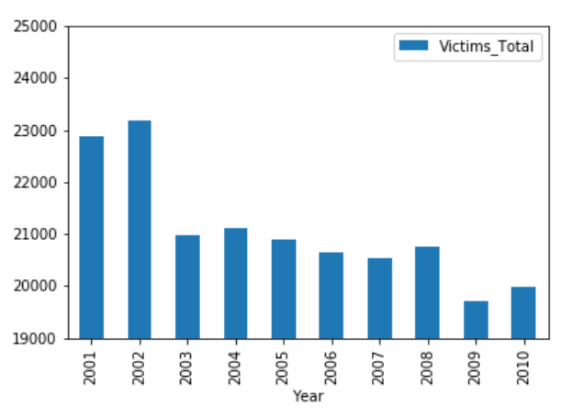

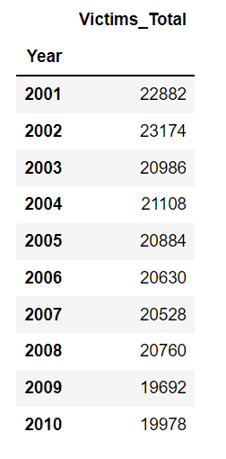

* view some basic statistical details like percentile, mean, std etc.

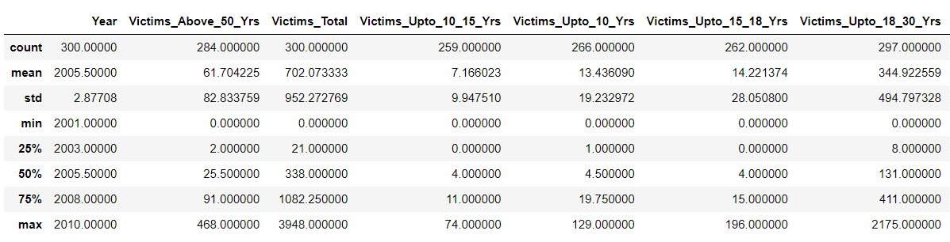

* Bihar has highest victims of murder. Andhra Pradesh has second highest number of victims. Surprisingly, even though the population of Andhra Pradesh was fewer than Gujarat, the no: of victims in Andhra Pradesh was much higher when compared with Gujarat.

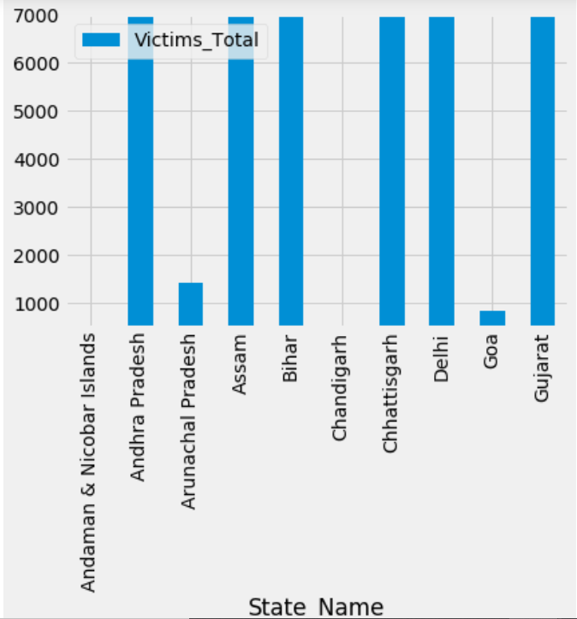

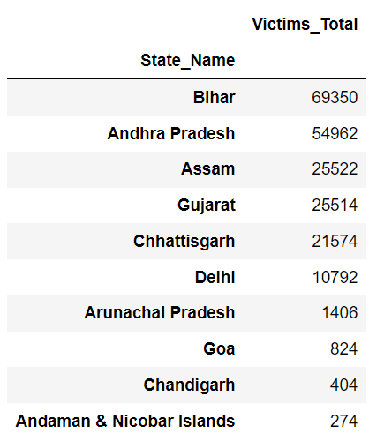

Similarly, even though population in Arunachal Pradesh is less than Goa, but the number of victims in Arunachal Pradesh is more when compared with Goa.

* People of age 18-30 are more likely to be get killed as compared to any of the age-group. After them people of age 30-50 are prone to be victim of murder

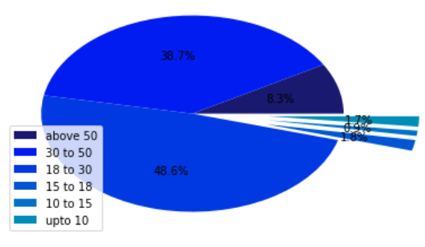

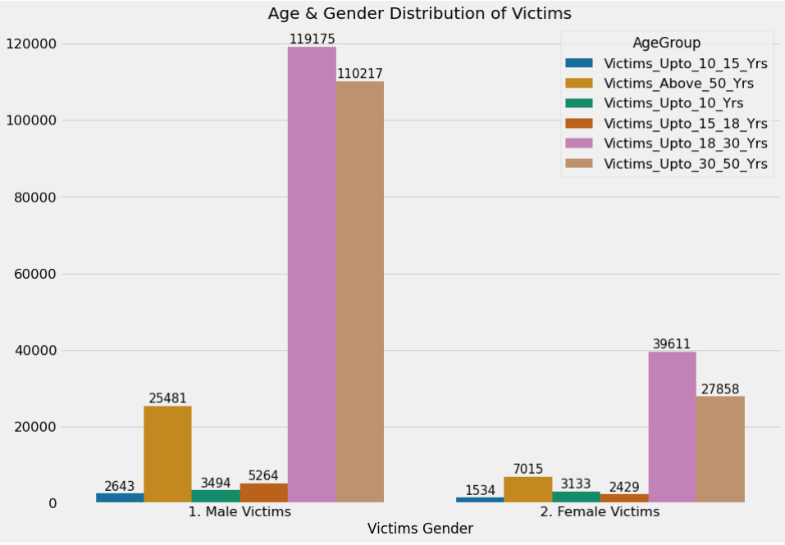

* Men were more likely than females to become murder victims. The number of male victims has declined over time, whereas the number of women victims has remained relatively constant.

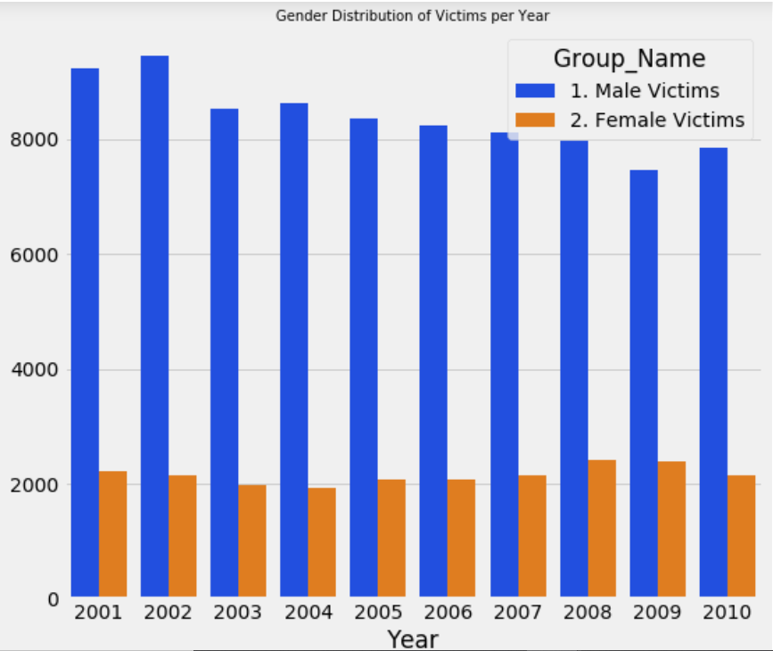

* Considering other 23 states in India, total murders per state is given below

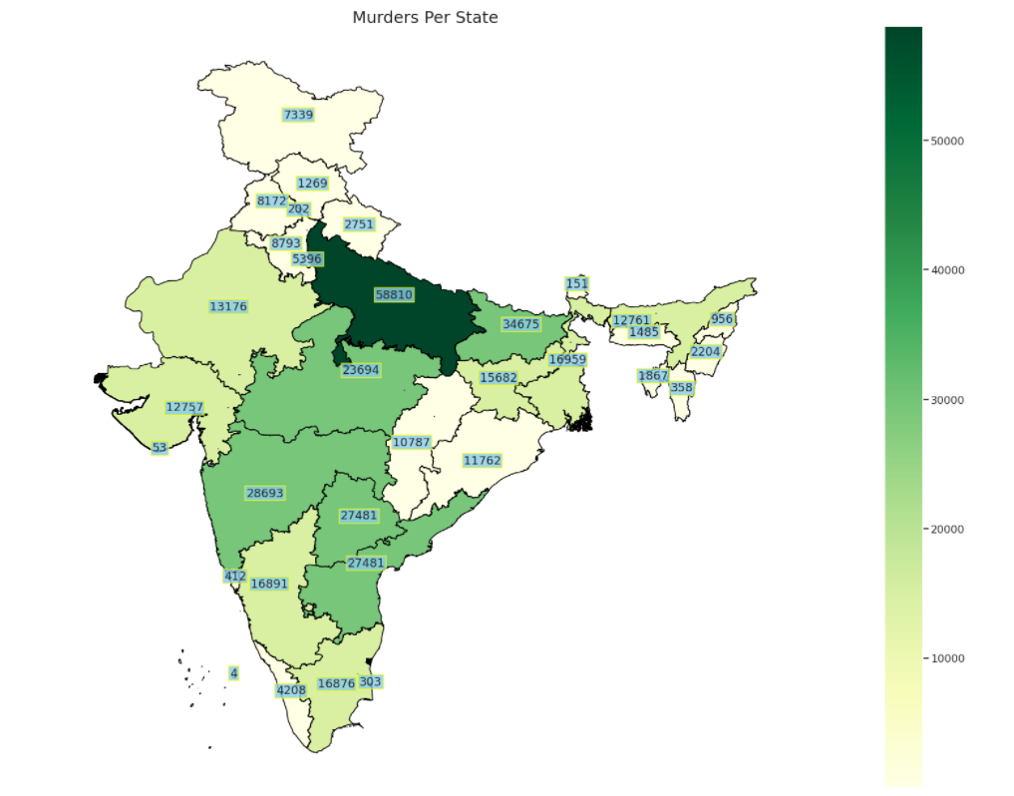

Conclusion

* Despite the fact that the country's murder rate has been steadily declining over the years states like Bihar, Andhra Pradesh and Assam have had a significant number of victims.
* Males between the ages of 18 and 30 are the most vulnerable.
* Children of age up to 15 years are less prone to murder.

Reference

<https://rajanand.atlassian.net/wiki/spaces/DATASET/pages/1310740/Crime+in+India>

<https://www.kaggle.com/rajanand/crime-in-india?select=32_Murder_victim_age_sex.csv>